From: Rubin, Jason
Sent: Thursday, July 1, 2021 12:28 PM
To: Frost, John <JFrost@republicservices.com>
Cc: Rodriquez, Tom <TRodriquez@republicservices.com>
Subject: Romulus System setpoints Update

All,

See attached updated setpoints for the Romulus System

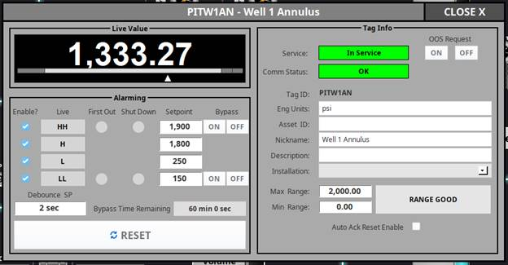
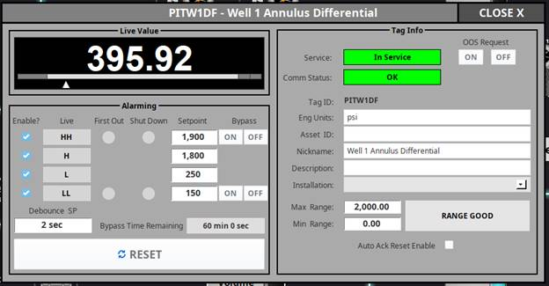
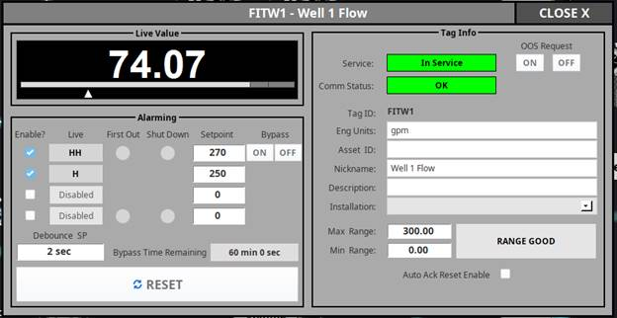

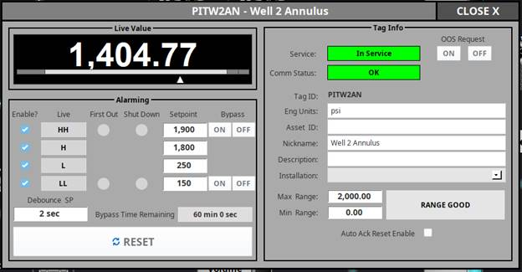
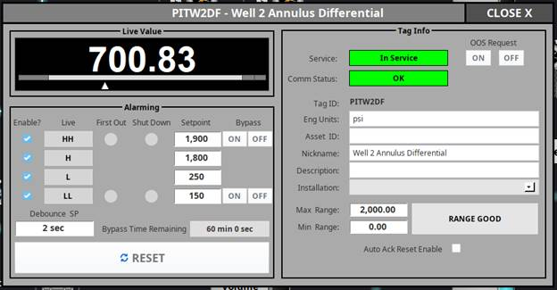
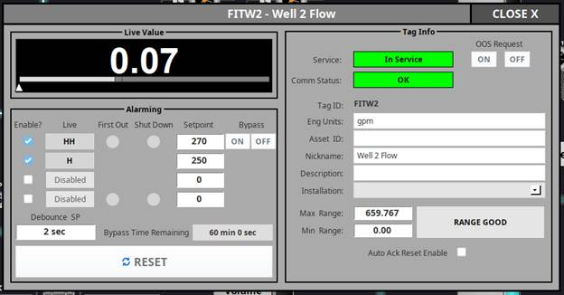

Jason Rubin
Well Engineering Manager

10613 W. Sam Houston Parkway N. Suite 300
Houston, TX 77064
e JRubin@republicservices.com
o 832-399-4586 c 346-260-7837
w www.RepublicServices.com

